2.1 Project Plan and Schedule:

* Week 1: Requirements Gathering
* Week 2: System Analysis and Planning
* Week 3: System Design
* Weeks 4-5: System Implementation
* Week 6: Testing and Debugging

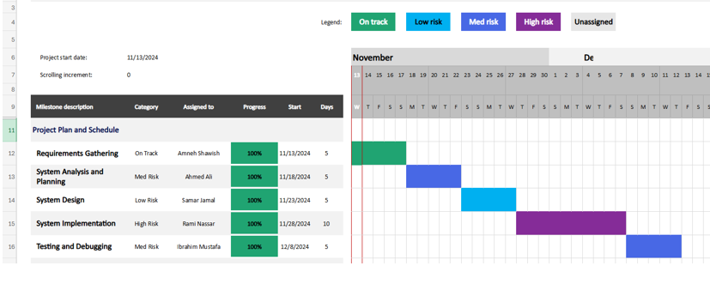

Figure 1: Gantt Chart of Project